Multiple protein sequence alignment using double-dynamic programming
William R. Taylor, Gisle Salensminde, Ingvar Eidhammer
Computers & Chemistry, Volume: 24, Issue: 1, January, 2000, pp. 3 - 12
Abstract
A method of multiple sequence alignment is described based on the double dynamic programming (DDP) algorithm previously used for treating structural constraints encountered in structure comparison and threading.
- Introduction
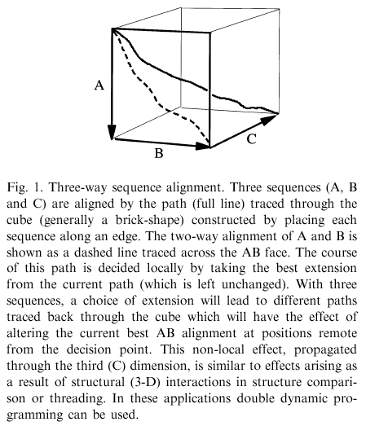
- Algorithms
2.1. Iterated double dynamic programming
2.1.1. Structure comparison using a structure alignment program
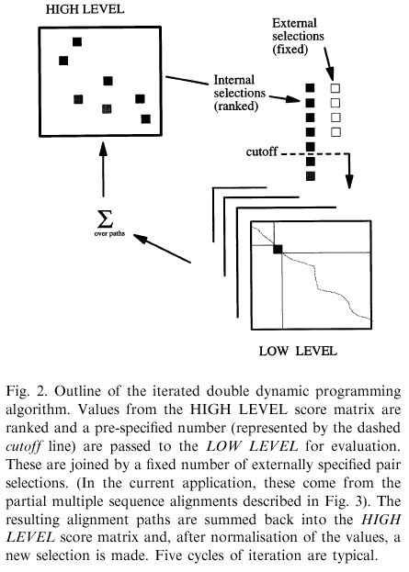
2.1.2. Iterating the selected pairs
2.2. Adapting SAP to sequence alignment
2.3. Partial multiple sequence alignment
2.3.1. Linked pairwise alignments
four sequences: A, B, C and D; if their pair scores rank (best to worst) as {AC, AD, CD, BA, BC, BD} then; the best clusters with each sequence are: A = C = ((D(AC))B), B = (C(BA)), D=(B((AD)C))
2.3.2. Pair concatenation
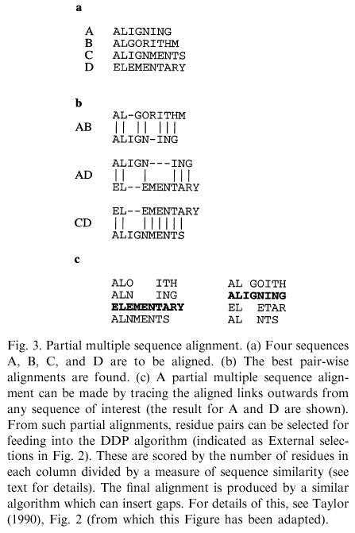
2.3.3. Column extraction
2.3.4. Column scoring
2.3.4.1. Colour score
2.3.4.2. Dayhoff score
- Implementation and testing
3.1. Parallelisation
3.2. Data and assessment
Created by: Chia-Mao Huang
Date: May 17, 2000

